Steps for using the Common Sense Wirewinder

Prepare wire for rolling
Remove wire from posts. Clips should be removed from the wire and wire should be laid out in an area where it will not catch obstacles. Tie a weight to the far end of the wire to cause drag or resistance and even pulling. A log chain works well.

Attach Wirewinder
Can be attached on any of the following that have hydraulics:
  - 3-point hitch
  - the front end of loader bucket
  - skid steer
  - hydraulic bale bed

Hook up hydraulic hoses
Make sure flow control valve is in the OFF position. Unit is plumbed so fluid will flow back to tractor with flow control valve in the OFF position. Engage hydraulics so flow is going to the flow control valve. Engage flow control valve to make sure shaft is turning in a counter-clockwise rotation. If shaft is turning the wrong direction, reverse the hoses.

Attach wire
Wire needs to go under the level wind pulley and over the spool assembly. Wrap wire around spool assembly three to four times. Tie wire to itself. DO NOT ATTACH WIRE TO SPOOL – this will make it impossible to remove the roll of wire from the spool when you have finished winding. Engage the flow control valve to cause tension on the wire.
Adjust upper link of the 3-point hitch or tilt cylinder so that there is a slight dip in the wire under the level wind pulley. Do NOT put more than a slight dip in the wire – this will cause undue wear and tear on the level wind assembly.
Level wind assembly should be oiled every one to two rolls that you wind. Oil the level wind assembly by dripping a trail of oil over the threads of the level wind. This will lubricate and wash off excess dirt that will cause undue wear on the unit. If you oil the assembly, the unit will give you many years of service.

Adjusting the by-pass/”clutch”
There are two different ways to use this winder. It can be used for either good wire or rusty wire:
  - Good wire - If wire is in good condition and can handle the pull, you can pull ¼ mile of barbwire to you while you sit still. If machine will not pull wire while you are sitting in one spot, there is a cap on the bottom of the flow control valve that can be removed. Inside of the cap there is a set- screw that can be used to tighten the amount of power the unit has. Turn to the right to increase the pressure. This setting should NOT be used if wire is in poor condition, as the wire would break and cause injury to the operator.
  - Rusty wire - The other way to use the Common Sense wirewinder is to loosen the pressure by turning the set-screw to the left to decrease pressure. This takes away power from the machine so it will try to pull but it cannot. You will need to drive into the wire and the winder will begin to roll up the wire as you back into it. Flow control valve should be adjusted so that it is trying to pull wire faster than you are driving into it so it will keep pressure on the wire, and you are not driving into it faster than the

machine is rolling the wire in. Clutch will not burn up like a friction clutch because it is made to allow extra fluid to bypass and flow back to the tractor.

High tensile wire
When rolling high tensile wire take off all three barb wire spool pieces and replace with the high tensile spool, set screw in. Pull the bolt that holds the level wind shaft to frame and replace with wire guide using the same bolt. Follow the directions for winding good wire.

Soft electric wire
When rolling soft electric wire take off all three barb wire pieces and replace with soft electric spool, set screw in. Follow directions for winding good wire.

Rolling the wire
If you are rolling up good wire, turn flow control valve slowly to begin rolling. Start at a slow pace and gradually increase speed by continuing to slowly turn the flow control valve. Bring wire in at a safe, controllable pace.
If you are rolling up rusty wire, adjust speed on flow control valve to about the middle of the dial. From inside your tractor, engage hydraulics and begin driving into the wire.
Make sure setting is set so that it is rolling the wire faster than you are driving into it.

Removing roll of wire
Loosen set-screw on the keeper disk. Remove keeper disk and set aside. Next, remove spool from the shaft by pulling the large circular hoop on the outside of the spool. Wire can be removed from the spool by continuing to hold onto the large circular hoop and dropping the bottom of the spool assembly onto a hard surface. This will release the wire from the spool assembly.

Reusing wire
Reinstall roll of wire onto the outer spool assembly. Then place the spool assembly onto the winder. Reinstall the keeper plate and tighten the set- screw. Put your tractor hydraulics in the float position and set the speed control on the flow control valve to the fastest speed. If you do not have a tractor with a float position, you can couple the two ends of hydraulic hose together to create a loop, so fluid can flow in a circle. Next, tie the end of the wire to a post and drive away from the post. You can decrease the speed lever on the flow control valve gradually to increase the amount of back pressure to keep the wire from bouncing or free spooling.
Specifications

- Three-point hitch is Cat. II.
- Three-point hitch can be removed and a different insert can be made to install unit to a skid steer, loader bucket, hydraulic bale bed, or other piece of equipment.
- Hydraulic fittings are ½” Male JIC. A different length of hose may be needed for each application, therefore hoses are not included with the winder.

Additional information: For parts or questions, contact Kelly Melius at 605-598-4157.

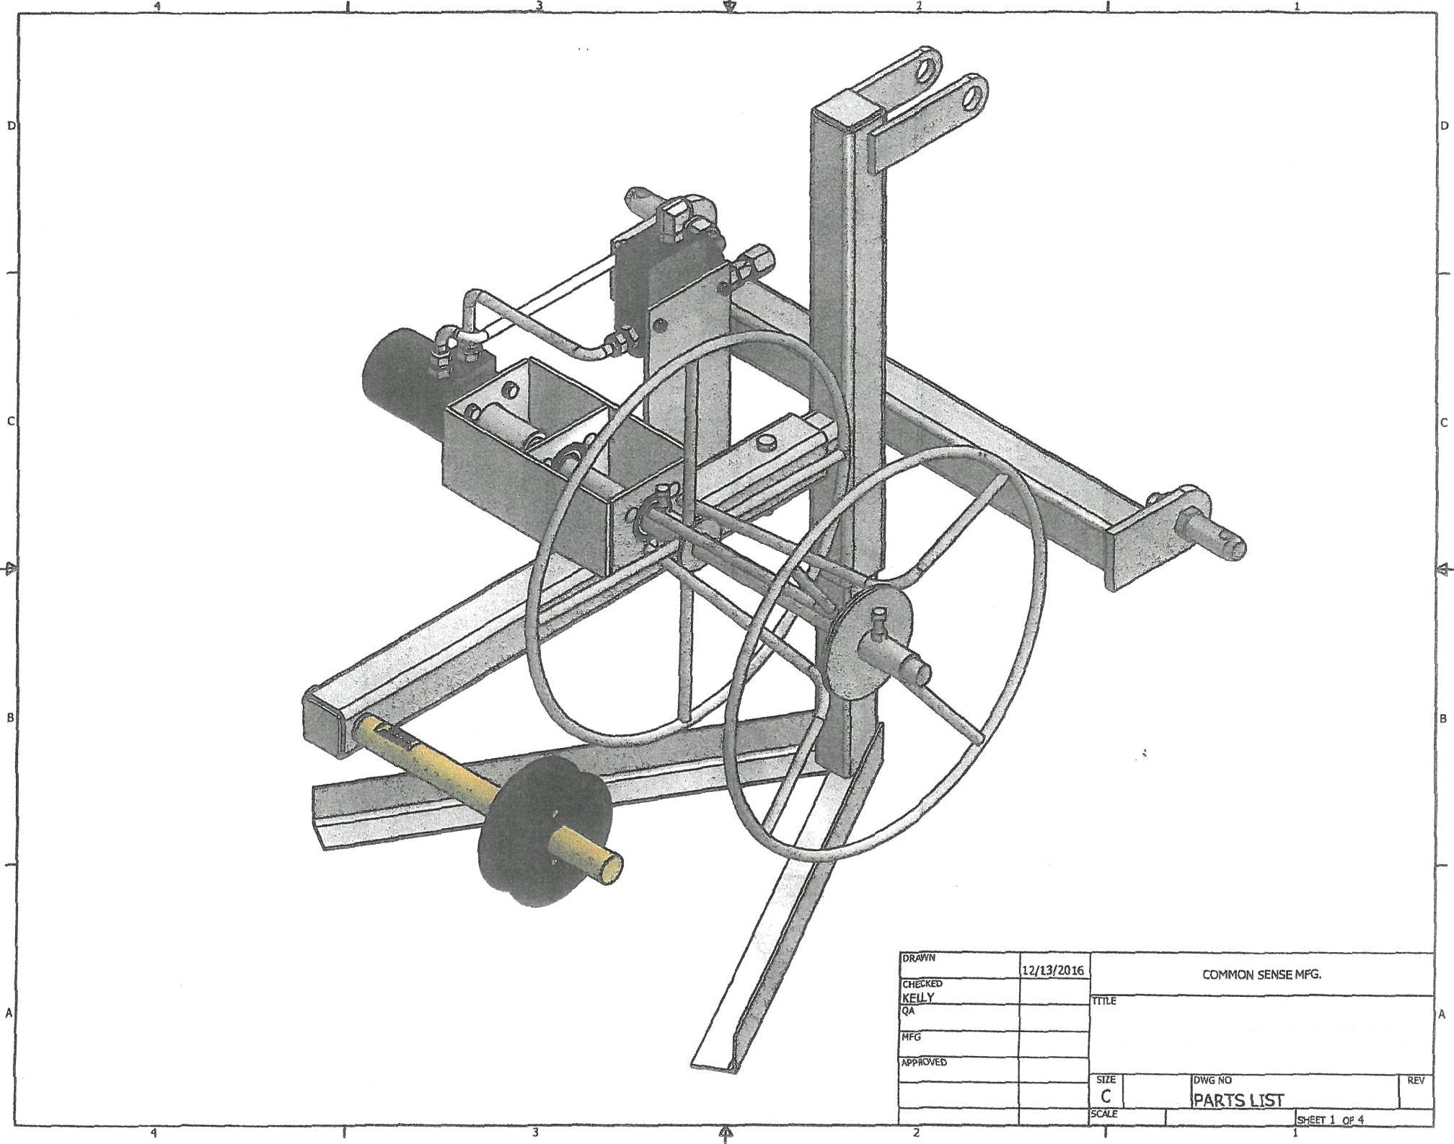

ARE VflNDERPARTSLISTBREAKDOWN

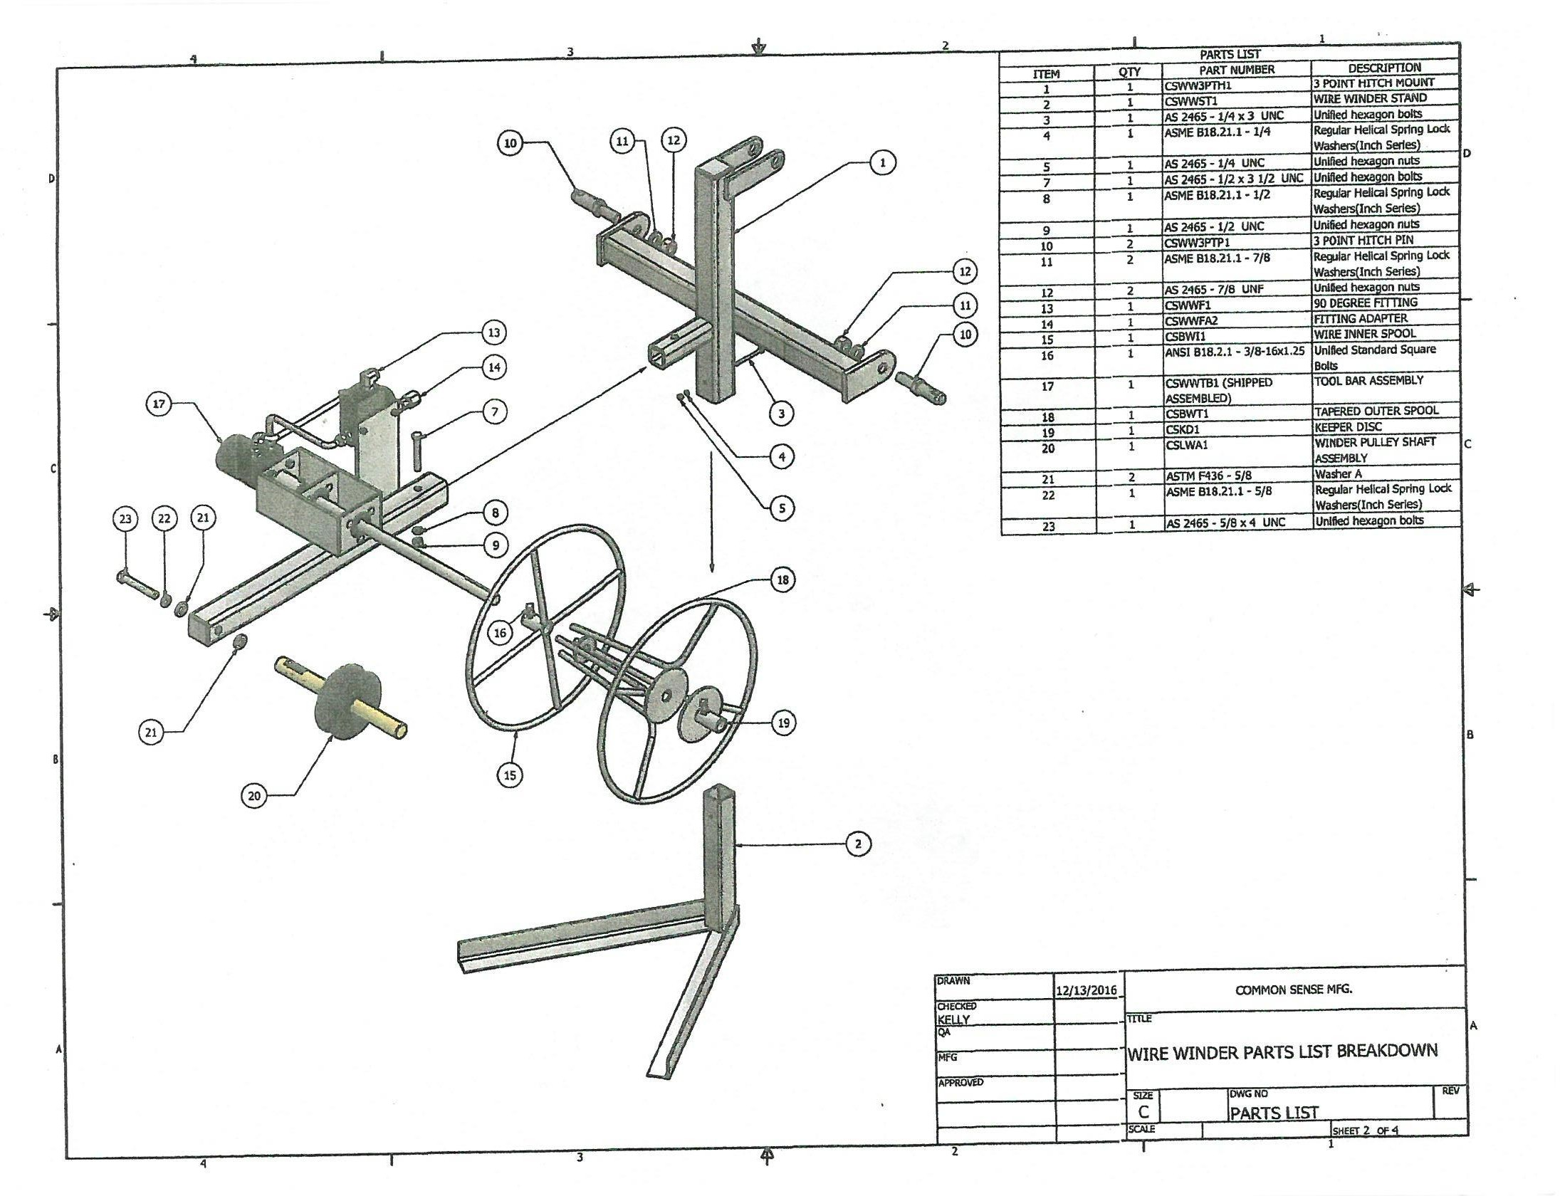

PATTT NUMBER 1-A
p TpTlort
MItE WTNDER PiJLLY SION
WTRE WTNDEA 80TTON

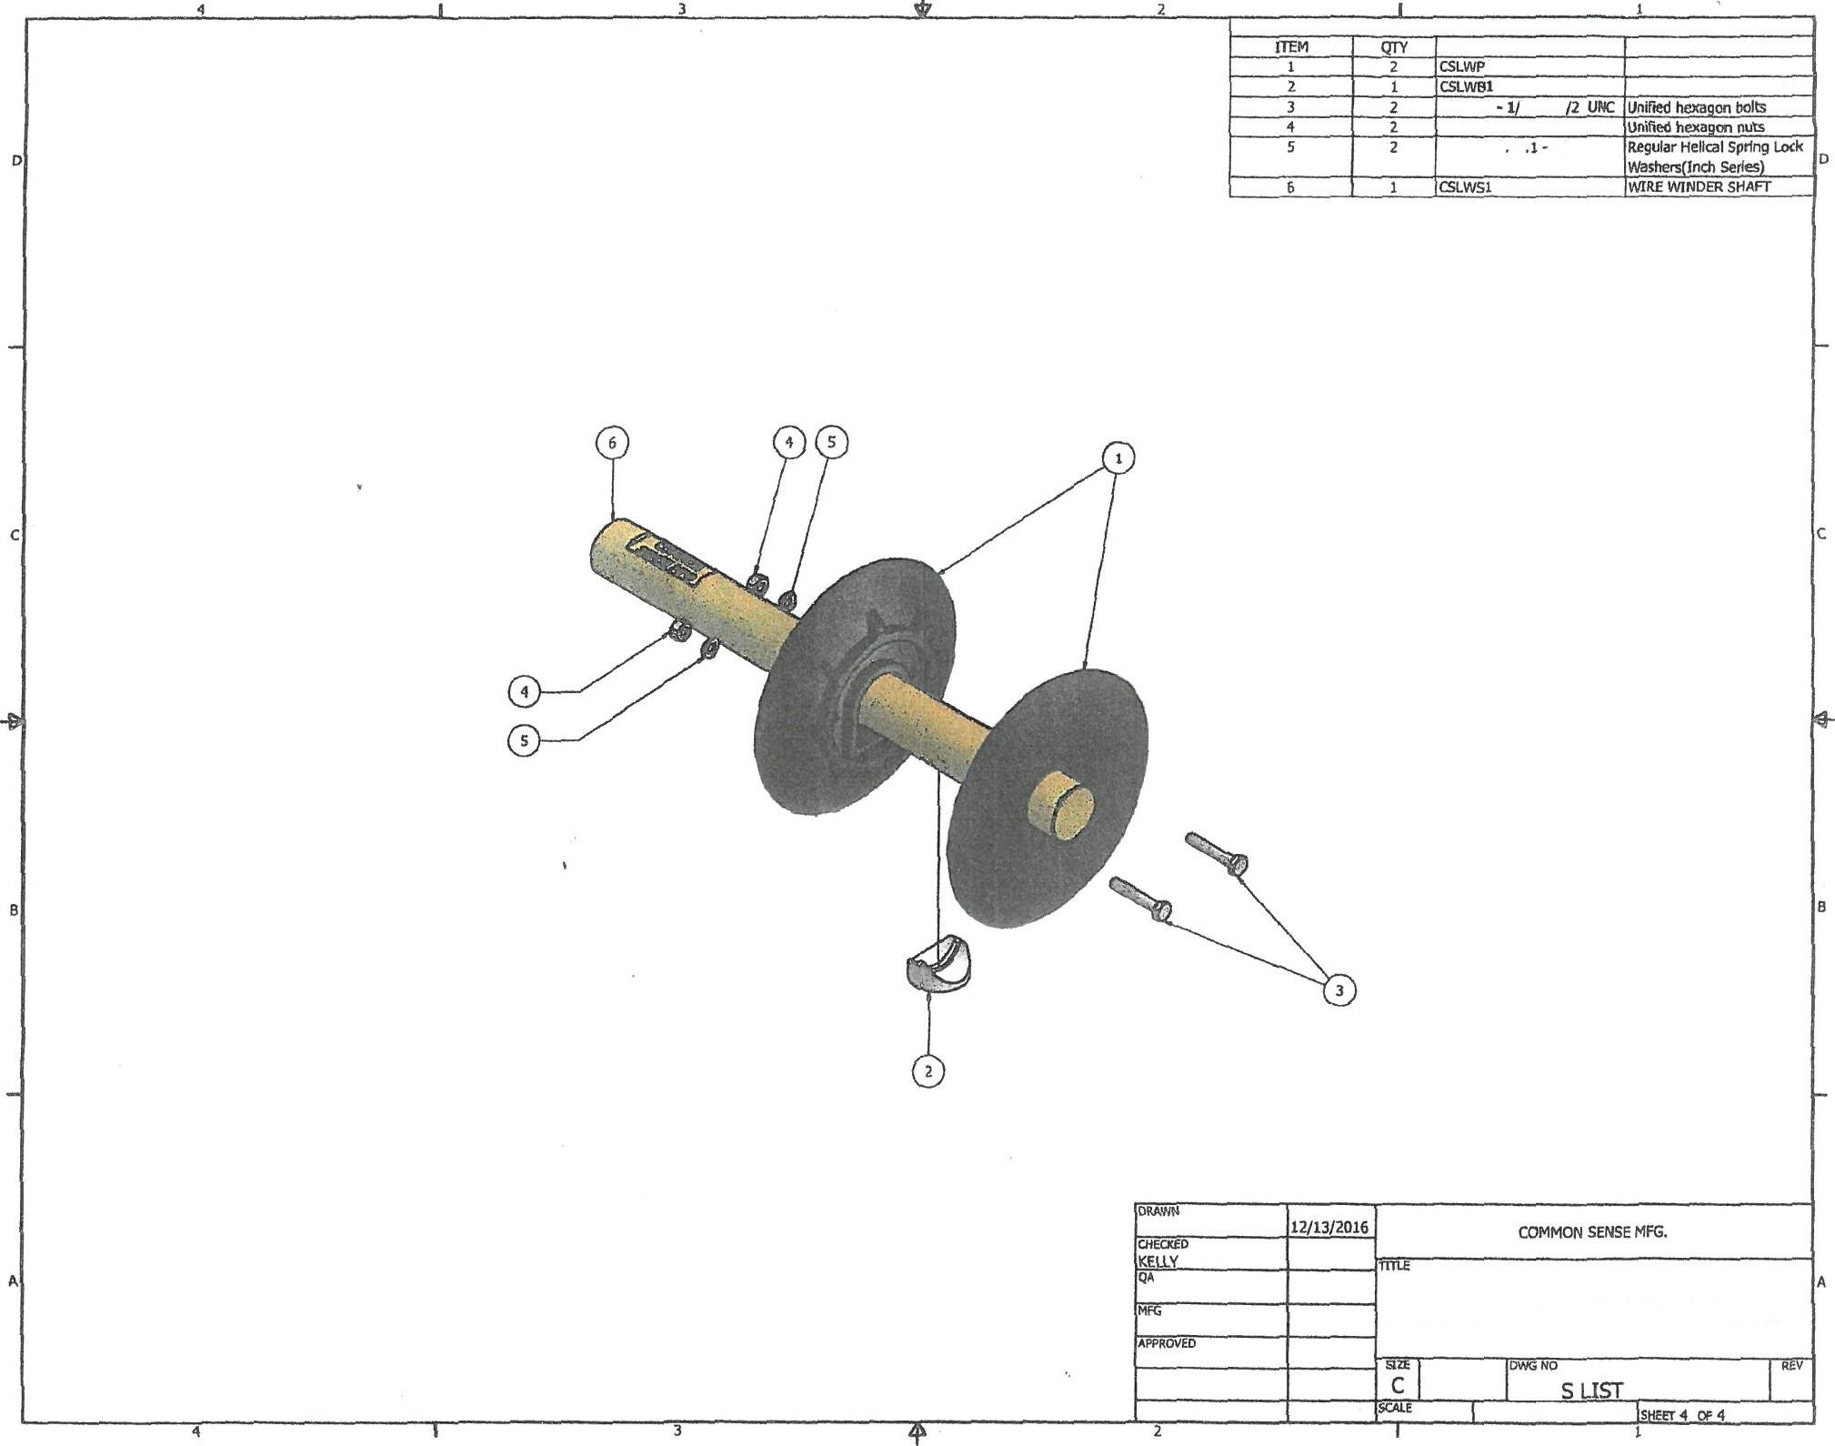
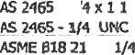

W\RE MNDER PARTS LIST BREAKDOWN

PART

